 | Information centre exhibition of  the Federal Republic of Germany  ZAK Doors & Windows  01. Dec. - 03. Dec. 2022, New Delhi, India |  |  |  |  | 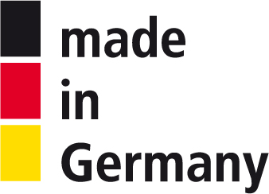
Organiser |  |  |  | In cooperation with
 | 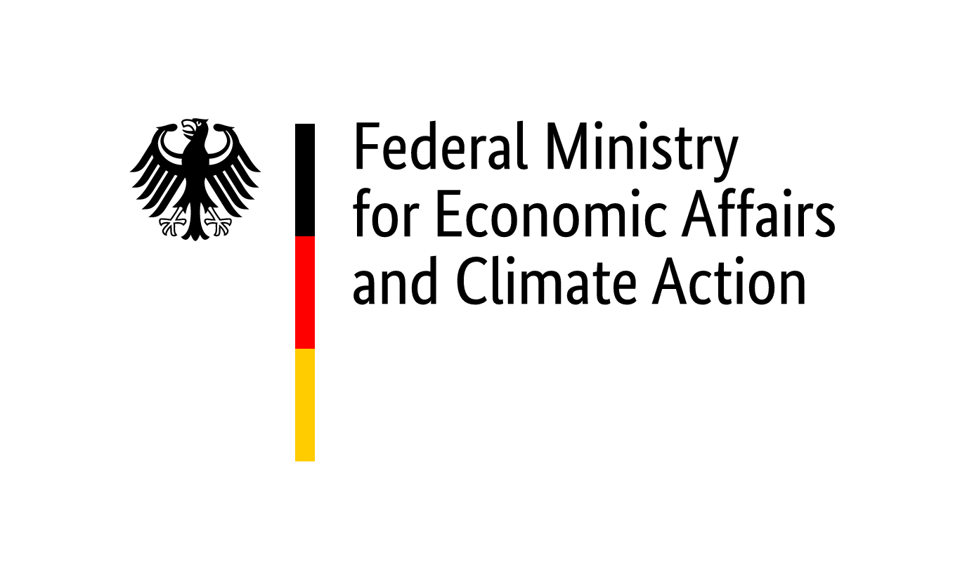 | 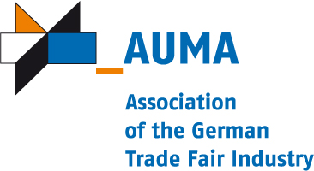
Realisation and exhibition management (implementation company within the meaning of the General Conditions of Participation)
 | 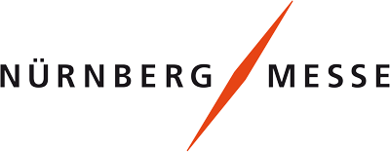 |  | NürnbergMesse GmbH  http://www.nuernbergmesse.de  Phone: +49 911 8606-0  Project manager:  Annika Bernhardt  annika.bernhardt@nuernbergmesse.de  Phone: +49 911 8606-8689  Fax: +49 911 8606-8694

Special Conditions of Participation
as supplement to the General Conditions of Participation of the Federal Republic of Germany at trade fairs and exhibitions abroad

1. Closing date for registrations
19. August 2022
It is pointed out that, on principle, the participation can only be conducted, should the minimum participation of
6 companies be reached. Registrations submitted after the closing date for registrations will not be considered.

2. Participation fee/s
The participation fees quoted are subject, where applicable, to statutory German value-added tax and to statutory foreign taxation
(e.g. VAT, sales tax) levied on services provided to the exhibitor by the implementation company. The participation fees according to No. 2.1. only cover a part of the total costs of services according to No. 4.
2.1. Participation fee for companies taking part in this official participation of the Federal Ministry for Economic Affairs and Climate Action in 2022 up to and including the 4th time:

EURO 400 / participant

2.2. Participation fee for companies taking part in this official participation of the Federal Ministry for Economic Affairs and Climate Action in 2022 for the 5th time or more:

• not applicable

2.3. Participation fee for exhibitors, that cannot sign the attached declaration regarding double-funding respectively participation of the public sector (public authorities or public companies):

EURO 1300 / participant

3. Mandatory Fee/s
• not applicable

4. Services
The payment of the participation fees according to No. 2 includes the following services:
4.1. Company-specific services
All materials and facilities shall be at the disposal of the exhibitor, on a rental basis, only for the duration of the event, and may in no way be damaged or modified. Damaged or modified components and devices shall be repaired or replaced at the expense of the exhibitor.
• By arrangement, presentation possibility for small exhibits on an exhibition space of 2 qm within the scope of the total concept
• Furnishings: 1 bistro table, 1 chair, 1 brochure rack
• Provision of wall advertising space inc. enlargement of reproducible artwork (photos, texts, graphics) (on request, with brochure filing); requirements effected by the implementation company
• General lighting of the information centre
• Distribution of company brochures on the information stand in exchange for interested parties’ business cards
• Supply of data on interested parties following the end of the fair
• By arrangement, use of meeting rooms in the information stand by company representatives

4.2. General services
• Technical and organisational support of exhibitors by the realisation company during preparation and realisation of the participation
• Setting up of an information stand with service arrangements / set-ups
• Entry into the website of the German participation or – if arranged – into the German participation directory (no liability shall be accepted for incorrect entries)
• Uniform setting design of the information centre in accordance with CI concept
• General lighting of the German participation
• Daily stand cleaning (cleaning of exhibits is the responsibility of the exhibitor)
• Security and stewarding service of the German participation if neccessary (no guarding of stands)
• Waste disposal service

4.3. Waiver
Waiving individual company specific or general services shall not constitute a claim for a reduction of the participation fee. Under no circumstances may uniform design elements be foregone.

5. Payment conditions
Duty to 20 % of the participation fee, based on the area size requested (according to No. 2), as well as of mandatory fees (according to No. 3), shall begin upon submission of registration in writing. Payment of this amount is due upon receipt of a corresponding invoice for payment in advance. On admission, payment shall be due of the outstanding amount, immediately upon receipt of the final invoice.

6. Company data
The exhibitor's personal data are processed by the implementation company for the purposes of contract execution and forwarded to third parties (for example, architects, agencies, freight forwarders, trade fair organisers, etc.). The implementation company also transmits the data to federal authorities (e.g. Federal Ministry for Economic Affairs and Climate Action, Federal Ministry of Food and Agriculture, Federal Office for Economic Affairs and Export Control), the Association of the German Trade Fair Industry (AUMA), to AUMA in particular for information about and for the evaluation of the foreign trade fair programme also by commissioned third parties as well as to the operator of the internet portal www.german-pavilion.com. Federal authorities may pass personal data on to members of the German Bundestag, to other public funding agencies and for statistical purposes and for evaluation to commissioned institutions. The personal data can also be passed on if required by the Bundesrechnungshof. Further information on data protection can be found on the homepage of the implementation company http://www.nuernbergmesse.de.

NürnbergMesse GmbH | Nuremberg, 11. April 2022

