Information centre of
the Federal Republic of Germany

SIFFP - International exhibition of facades, windows and doors
30. Nov. - 03. Dec. 2022, Algiers, Algeria
 |  | Organiser | In cooperation with
NürnbergMesse GmbH  Messezentrum  90471 Nuremberg  Germany |  | 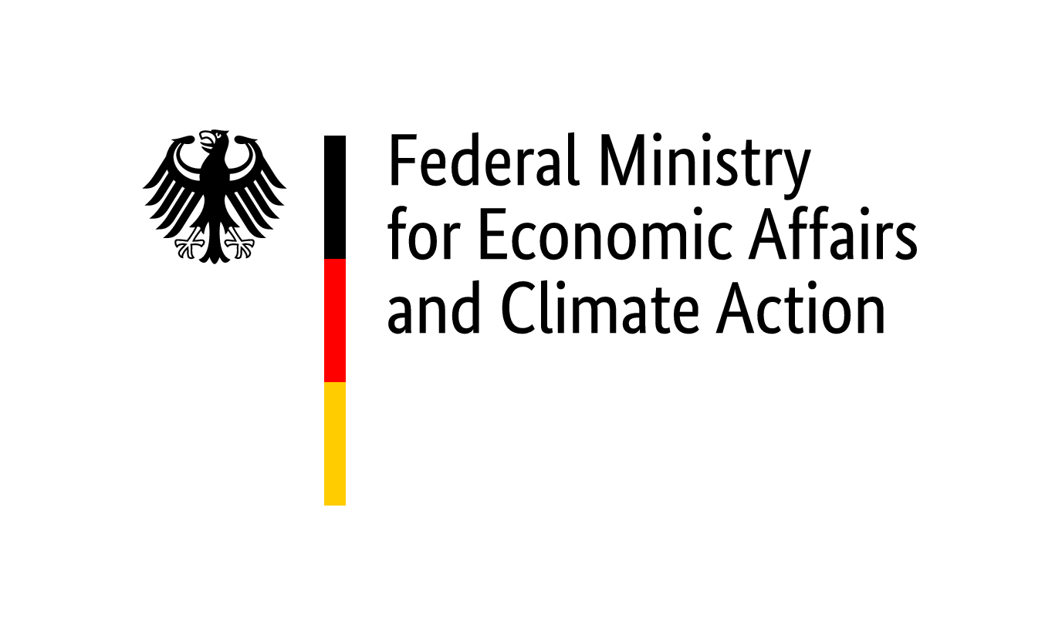 |  | 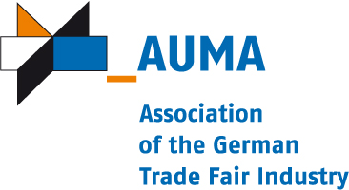
Realisation and exhibition management (implementation company
within the meaning of the General Conditions of Participation)
NürnbergMesse GmbH
http://www.nuernbergmesse.de
 |  | Phone: +49 911 8606-0  Project manager:  Veronika Zinkl  veronika.zinkl@nuernbergmesse.de  Phone: +49 911 8606-8687  Fax: +49 911 8606-8694 |  |  | 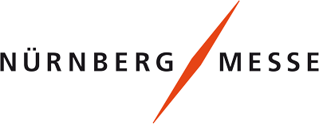
Registration | Closing date for registrations: 15. August 2022
We hereby register as participants at the above-mentioned participation.

1. Participant
 | Company name:
 | Street: |  | Contact partner:
 | Postcode & town: |  | Phone:
 | Federal state: |  | Fax:
 | VAT ID: |  | E-Mail:

2. Required exhibition space and mandatory fee/s
All amounts indicated below are subject, where applicable, to statutory German and to statutory foreign taxation
2.1. Participation up to and including the 4th time:
à EURO 970,00 / participant
2.2. Participation for the 5th time or more:
• not applicable
2.3. Participation of exhibitors, which cannot sign the attached declaration regarding double-funding respectively participation of the public sector (public authorities or public companies):
à EURO 3400,00 / participant
3. Mandatory fee/s (do not depend on number of participations)

• Registration fee 300,00 € / exhibition company

4. Exhibition goods (At information stand: product range) Dimensions Weight
•
•
•
We have noted and acknowledged the General and Special Conditions of Participation. We undertake only to exhibit products which are produced according to No. 8 of the General Conditions for Participations of the Federal Republic of Germany at trade fairs and exhibitions abroad. We have completed and enclosed the registration appendices. We agree to the computer-aided recording, storage, and forwarding of company details to third parties. We declare, that insolvency proceedings have not been filed or opened for our assets or that we have not issued or are obliged to make a statutory declartion in accordance with sec. 802c Civil Code of Civil Procedure (ZPO) or sec. 384 of the German Tax Code (AO) 1977.

Place, date | Company stamp & legally binding signature

Enclosures:
• Appendix to registration form: Special Conditions of Participation
• Appendix to registration form: General Conditions of Participation
• Appendix to registration form: Declaration regarding double-funding resepectively participation of the public sector
• Appendix to registration form: Alternative address for invoices
• Confirmation of assumption of costs

Information centre of the Federal Republic of Germany

SIFFP - International exhibition of facades, windows and doors
30. Nov. - 03. Dec. 2022, Algiers, Algeria

Appendix to registration form
(Mandatory: please return with the registration form)

Exhibitor
 | Company:
 | Street: |  | Managing Director:
 | ZipCode, Town: |  | Commercial Reg.-No.:
 | Federal state: |  | District court:
 |  |  | Contact partner:

Declaration regarding double-funding respectively participation of the public sector
(public authorities or public companies)
With our registration for the Information centre of the Federal Republic of Germany at the

SIFFP - International exhibition of facades, windows and doors
30. Nov. - 03. Dec. 2022, Algiers

I hereby declare/we hereby declare, that I/we do not receive any institutional fundings granted/covered by public resources.
I hereby declare/we hereby declare, that I/we do not receive any further public support out of project fundings for the participation at this trade fair/exhibition.
I hereby declare/we hereby declare, that my/our company is not a federal, state or municipal authority, is neither a state development institution nor a any other legal entity under public law.
I hereby declare/we hereby declare that my/our company is not directly or indirectly majority-owned by a religious community/communities or by a legal entity/entities under public law.

Place, Date | Company stamp & legally binding signature

Information centre of the Federal Republic of Germany

SIFFP - International exhibition of facades, windows and doors
30. Nov. - 03. Dec. 2022, Algiers, Algeria

Alternative address for invoices

Exhibitor
Company:
Street:
ZipCode, Town:
Federal state:

Exhibition
SIFFP - International exhibition of facades, windows and doors
30. Nov. - 03. Dec. 2022, Algiers

Alternative address for invoices
 | Company:
 | Address:
 | ZipCode:
 | Postbox: |  | Name:
 | Postbox ZipCode: |  | Phone:
 | Town: |  | Fax:
 | Country: |  | E-Mail:

Place, Date | Company stamp & legally binding signature

Information centre of the Federal Republic of Germany
Informationszentrum der Bundesrepublik Deutschland

SIFFP - International exhibition of facades, windows and doors
30. Nov. - 03. Dec. 2022, Algiers, Algeria
 |  | Organiser | In cooperation with
NürnbergMesse GmbH
Messezentrum
90471 Nuremberg
Germany
 |  | Realisation and exhibition management
NürnbergMesse GmbH
http://www.nuernbergmesse.de
Phone: +49 911 8606-0
Project manager:
Veronika Zinkl
veronika.zinkl@nuernbergmesse.de
Phone: +49 911 8606-8687
Fax: +49 911 8606-8694
Confirmation of assumption of costs regarding the above mentioned Information centre
Kostenübernahmeerklärung zum oben genannten Informationszentrum

1. Exhibitor / Aussteller
 | Company/Firma:
 | Street/Straße:
 | ZipCode, Town/PLZ, Ort: |  | ID No./Ident-Nr.:
 | Federal State/Bundesland: |  | Order No./Auftrags-Nr.:

We request you to enforce your claims resulting from our applications for the above event and from our participation in the said event against the debitor stated under 2, who is jointly and severally liable. We are aware that we will be released from our obligation to pay only upon complete settlement of your claims. | Wir bitten, Ihre Forderungen, die aus unserer Anmeldung zur obigen Veranstaltung und unserer Teilnahme an dieser entstehen, gegenüber dem unter Ziff. 2 aufgeführten, gesamtschuldnerisch haftenden Rechnungsempfänger geltend zu machen. Uns ist bekannt, dass wir erst nach vollständigem Ausgleich der Ihnen entstehenden Forderungen von unserer Verpflichtung zur Zahlung frei werden.

_________________________________________________________
Place / Date; Ort/ Datum Stamp/ Legally binding signature; Stempel/ Rechtsverbindliche Unterschrift

2. Debitor / Rechnungsempfänger
 | Company/Firma:
 | Address/Straße:
 | ZipCode/PLZ/:
 | Postbox/Postfach: |  | Person in charge/zustädnig:
 | Postbox ZipCode/PPZ: |  | Phone/Telefon:
 | Town/Ort: |  | Fax/Fax:
 | Country/Land: |  | E-Mail/E-Mail:

I/We hereby declare that I/we by way of collateral promise assume joint and several liability for all claims which arise in favour of the creditor resulting from the participation or a possible cancellation of participation of the company stated under 1 in the above event. | Ich/wir erkläre(n) hiermit, dass ich/wir im Wege des Schuldbeitritts die gesamtschuldnerische Haftung für alle Forderungen übernehme(n), die dem Gläubiger aus der Teilnahme oder einer eventuellen Absage der Teilnahme des unter Ziff. 1 genannten Ausstellers an der obigen Veranstaltung entstehen.

_________________________________________________________
Place / Date; Ort/ Datum Stamp/ Legally binding signature; Stempel/ Rechtsverbindliche Unterschrift

