Title in English: The man in the moon

Subtitle: What really happened!

Prof. J.C. Doe, Company, Town;

Heading 1
This is where the body of the text begins ljkoasdf jklofasd jkloasdf jkl asdf jkloasdf jklo asdf lo jkadfs jkloadfs asdf 9uierfiodgfhjasdfjkasdf jkookjasdfo ajkldfj haoklskldfjjkloklo jojklojkl klo jlojk lo jklojk l jkoljko jl kol jkodf jklo asdf klo jasdf l jkoasdfjkl oasdf kl joasdf jkloasdf jkloasdf jkl oadfs

Heading 2
This is where the body of the text begins ljkoasdf jklofasd jklod asfljkoasdf jklo dasf jklosdf ajklodfas ljkoasdf klo jasdf l jkoasdfjkl oasdf jkloasdf jkl asdf jkloasdf sdf jklo dfas jklo sdfa jklodfas jklofasd jkloasdf

Table 1: Table title here

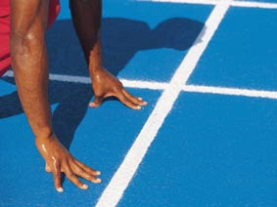
Fig. 33: Caption here jkloasdfjklodfas jkloasdf jklo asdf jkloasdf jklo asdf jkloasdf jkl ajklo asdf jkloasdf jklo dasf jkloasdf jkloasdf jkl oasdf jkloasdf jklo

[1] Reference here jkl oasdf jkloasdf jkloasdf kljasdf kljasdf l jkasdf

